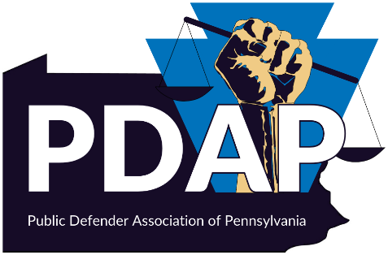

Chief’s Meet-up
October 22, 2024
3:00 – 4:30

Agenda
1. Strategies for Successful Recruiting
- success stories from last years career event

2. How a successful internship program leads to hiring new Defenders
- Nuts and Bolts of operating a successful internship program
- Students can be paid through their schools/ fellowships program - your office does not need to compensate them.
- Interns become Attorneys

3. Navigating the 3rd year law student conundrum (offering a job to someone who hasn't taken the bar yet)
- How an office was able to work with their commissioners to change their hiring practices.
- Clerk to Attorney Program

4. Logistics of the Public Defender Career Day with Pitt Law
- Deadlines and Important Dates
- Submitting Job Postings
- Student Selections
- Virtual Interviews

5. Q/A with the Professional Development Office at Pitt Law.

