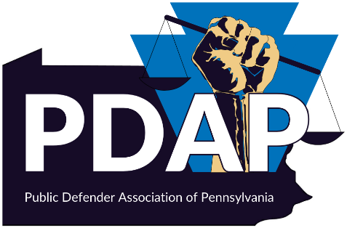
APPELLATE ACADEMY 2024
OCTOBER 10TH and 11th
CENTRAL HOTEL – HARRISBURG, PA
CENTRAL D&E

Agenda
DAY 1 – October 10th, 2024
8:30 – 9:00 – Registration / Welcome Remarks
9:00 – 9:30 – Rules Update
9:30 – 11:00 – Basics on Post Sentence Motions and Appeals
11:00 – 12:30 – WORKSHOP – Writing Questions Complained Of or Post Sentence Motions
12:30 – 1:15 – LUNCH
1:15 -2:15 – AI – The Good, the Bad, the Unethical (?)
2:15 – 4:15 – AI Presentations – Justice Text, Lexis, Reduct & Westlaw
4:15 -5:15 – The Perils and Pitfalls of AI in Appellate Practice?
Superior Court Justices – President Judge Lazarus
5:30 – 7:30 – Happy Hour (Hotel Lobby)

DAY 2 – October 11th, 2024
9:00 – 10:15 – Sentencing / Probation Reform
10:15 – 10:45 – Issue Spotting
10:45 – 11:00 – Break
11:00 – 11:45 – Research and Writing
11:45 – 12:15 – Allocator Questions / Collaboration
12:15 – 2:00 – Working Lunch
WORKSHOPS Content and Organization of Briefs / Writing an Allocator Question

