NATIONAL PUBLIC DEFENSE WORKLOAD STUDY FINAL RESULTS CHART
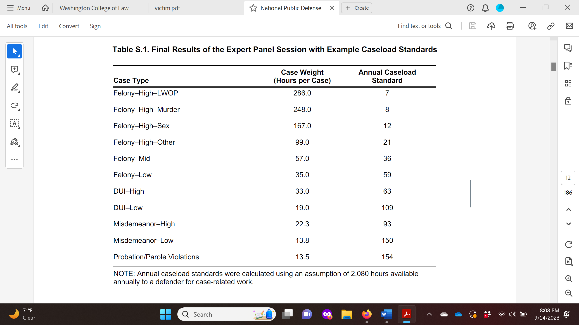
https://www.rand.org/pubs/research_reports/RRA2559-1.html Released 9/12/23

