**Public Defender Mutual Support Space**

**Tuesday September 5th -** Compassion Fatigue: a loss of compassion due to working with those who are traumatized and experiencing vicarious trauma. (Zoom Meeting 9/5/23 at 2:00 PM Meeting ID: 861 2237 5351 Passcode: 203104)

**Thursday September 21st -** Healthy boundaries with clients: The complexity of the responsibility to clients while not being able to solve the impacts of poverty and trauma. How to set and maintain healthy boundaries to protect against burnout and compassion fatigue. (Zoom Meeting 9/21/23 at 7:00 PM Meeting ID: 818 8907 2621 Passcode: 671762)

The Public Defender Association of Pennsylvania offers a Mutual Support Space, facilitated by Licensed Professional Counselor Lauren Hogsett, open to all members of Public Defender offices throughout the Commonwealth of Pennsylvania. The stressors from the nature of our work have demonstrated a need for a confidential and supportive environment. This Public Defender Mutual Support Space has been created as a venue to process these challenges with peers to increase health and wellness in the work setting.

Group Sessions will be facilitated by a Licensed Professional Counselor and take place on the first Tuesday of each month at 2:00 PM and the third Thursday of each month at 7:00 PM via Zoom.

**Thursday, September 21st, 2023, at 7:00 PM**

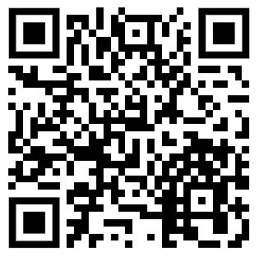

Meeting ID: 818 8907 2621

Passcode: 671762

**Tuesday, September 5th, 2023, at 2:00 PM**

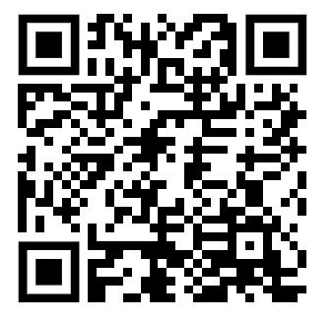

Meeting ID: 861 2237 5351

Passcode: 203104

Objectives

* Provide education on common challenges and stressors for Public Defenders and other members in the office.
* Provide a supportive, confidential, and safe environment for peers in Public Defender's offices to meet and share challenges and impact related to the work of the office.