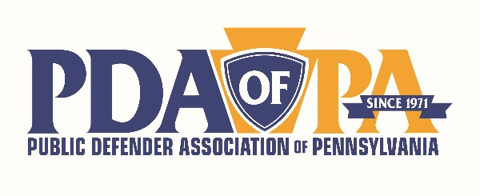
2023 CHIEF’s CONFERENCE AGENDA
MONDAY, 5/15/23
- 8 to 9 Breakfast
- 9 to 10 Legislation Update on Public Defense funding
- 10:15 to 11:15 Pennsylvania Commission on Crime & Delinquency (PCCD) Grants 101
- 11:15 to 12:15 Juvenile Justice Task Force Update
- 12:15 to 1:15 LUNCH
- 1:15 to 2:15 National Workload Standards for Public Defenders
- 2:30 to 3:15 Chief’s forum on case management software needs
- 3:00 to 5:15 Case Management Software company presentations

- 5:30 to 7:00 Cocktail Reception, sponsored by
- 7:00 to 8:30 Dinner
TUESDAY, 5/16
- 8 to 9 BREAKFAST
- 9 to 10:15 Creative Solutions in Public Defense (come learn ways other offices are working
with external partners to do more for our clients)
- 10:30 to 12:00 2023 Sentencing Guidelines Revision + Department of Corrections programming
- 12:00 to 1:00 LUNCH + PDAP General Meeting
- 1:15 to 2 Chiefs Provide Solutions: How Do I…

