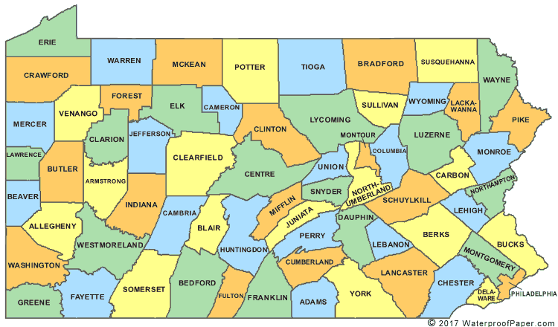

|  |
| --- |
| First Class: pop 1,500,000 or more |

|  |  |  |  |
| --- | --- | --- | --- |
| County | # of Lawyers | # of Social Workers | # of Investigators |
| Philadelphia  Child Advocacy Unit | 201 (total)  22 | 67 (total)  34 | 27  0 |

|  |
| --- |
| **Second Class: Pop. of 1,000,000 to 1,499,999** |

|  |  |  |  |
| --- | --- | --- | --- |
| County | # of Lawyers | # of Social Workers | # of Investigators |
| **Allegheny** | **95** | **3** | **12** |

|  |  |  |  |  |  |  |  |  |  |  |
| --- | --- | --- | --- | --- | --- | --- | --- | --- | --- | --- |
| |  |  |  |  |  |  |  |  |  |  | | --- | --- | --- | --- | --- | --- | --- | --- | --- | --- | | |  | | --- | | **2a: pop. 500,000 to 999,999** |  |  |  |  |  | | --- | --- | --- | --- | | County | # of Lawyers | # of Social Workers | # of Investigators | | **Bucks**  **Delaware**  **Montgomery** | **26 FT**  **41 FT**  **42** | **2**  **3**  **3** | **3**  **1**  **4** | | |

|  |  |  |  |  |  |  |  |  |  |
| --- | --- | --- | --- | --- | --- | --- | --- | --- | --- |
| |  | | --- | | **3rd: pop. 210,000 to 499,999** |  |  |  |  |  | | --- | --- | --- | --- | | County | # of Lawyers | # of Social Workers | # of Investigators | | **Berks**  **Chester**  **Cumberland**  **Dauphin**  **Erie**  **Lackawanna**  **Lancaster**  **Lehigh**  **Luzurne**  **Northampton**  **Westmoreland**  **York** | **24 FT**  **30 FT**  **26 FT**  **9 FT + 11 PT**  **4 FT, 10 PT (w. Chief)**  **25 FT**  **15 FT + 16 PT**  **17 FT + 9 PT**  **3 FT + 15 PT (w. Chief)**  **10 FT + 5 PT**  **26** | **1**  **1**  **2**  **0**  **1**  **1**  **2**  **3**  **0**  **0**  **0** | **2**  **2**  **2**  **2**  **1** **PT**  **4**  **2**  **5**  **2-3**  **1**  **1** | |

|  |
| --- |
| 4th: pop. 145,000 to 209,999 |

|  |  |  |  |
| --- | --- | --- | --- |
| County | # of Lawyers | # of Social Workers | # of Investigators |
| **Beaver**  **Butler**  **Cambria**  **Centre**  **Fayette**  **Franklin**  **Monroe**  **Schuykill**  **Washington** | **8 FT**  **7 FT**  **11 FT** | 1 doubles as invest  1  0  0 | 1 doubles as SW  1  2 |

|  |  |  |  |  |  |  |  |  |  |
| --- | --- | --- | --- | --- | --- | --- | --- | --- | --- |
| |  | | --- | | **5th: pop/ 90,000 to 144,999** |  |  |  |  |  | | --- | --- | --- | --- | | County | # of Lawyers | # of Social Workers | # of Investigators | | **Adams**  **Blair**  **Lawrence**  **Lebanon**  **Lycoming**  **Mercer**  **Northumberland** | **4 FT**  **5 FT, 5 PT**  **6 FT, 1 PT**  **8 FT**  **5 FT + 5 PT**  **4 FT + PT Chief** | **0**  **0**  **0**  **1? doubles as paralegal**  **1 (is also an inv. & para)**  **0** | **1 PT**  **0**  **0**  **0**  **1 Ft + 3 PT + the SW**  **0** | |

|  |
| --- |
| **6th: pop. 45,000 to 89,999** |

|  |  |  |  |
| --- | --- | --- | --- |
| County | # of Lawyers | # of Social Workers | # of Investigators |
| **Armstrong**  **Bedford**  **Bradford**  **Carbon**  **Clarion**  **Clearfield**  **Clinton**  **Columbia**  **Crawford**  **Elk**  **Greene**  **Huntingdon**  **Indiana**  **Jefferson**  **McKean**  **Mifflin**  **Perry**  **Pike**  **Somerset**  **Susquehanna**  **Tioga**  **Venango**  **Warren**  **Wayne** | **4 PT**  **3 FT + 3 PT**  **2 FT, 2 PT**  **5 FT, 1 PT**  **1FT**  **2 FT**  **2 FT**  **6 PT**  **1 FT + 2 PT**  **3 FT 1 PT**  **1 FT**  **3 FT**  **1 FT + 1 PT**  **2 FT** | **0**  **0**  **0**  **0**  **0**  **0**  **0**  **0**  **0**  **0**  **0**  **0**  **0**  **0** | **0**  **0 (hire as needed)**  **0**  **1 (splits job)**  **0**  **0**  **0**  **0**  **0 (hire as needed)**  **0**  **0**  **1**  **Hire as needed**  **Hire as needed** |
|  |  |  |  |

|  |  |  |  |  |  |  |  |  |  |
| --- | --- | --- | --- | --- | --- | --- | --- | --- | --- |
| |  | | --- | | 7th: pop 20,000 to 45,000 |  |  |  |  |  | | --- | --- | --- | --- | | County | # of Lawyers | # of Social Workers | # of Investigators | | **Juniata**  **Snyder**  **Union**  **Wyoming** | **1 FT**  **1 FT + 2 PT**  **1 FT + 2 PT** | **0**  **0**  **0** | **0**  **0**  **0** | |

|  |  |  |  |  |  |  |  |  |  |
| --- | --- | --- | --- | --- | --- | --- | --- | --- | --- |
| |  | | --- | | **8th: under 20,000** |  |  |  |  |  | | --- | --- | --- | --- | | County | # of Lawyers | # of Social Workers | # of Investigators | | **Cameron**  **Forest**  **Fulton**  **Montour**  **Potter**  **Sullivan** |  |  |  | |