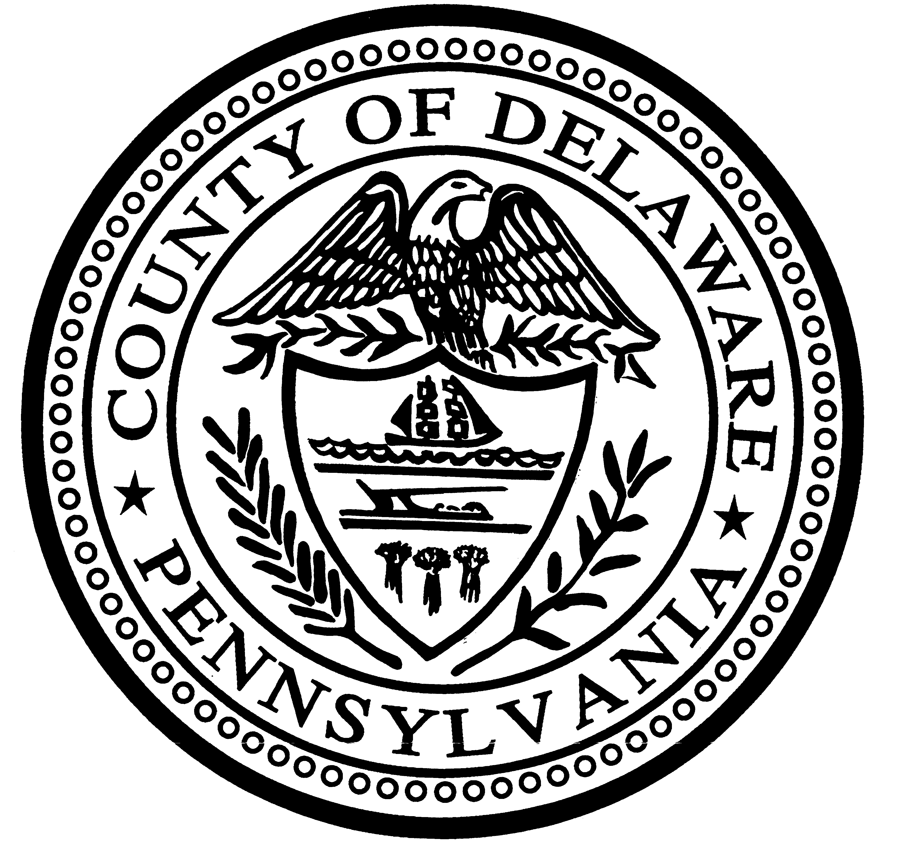


COUNTY OF DELAWARE
GOVERNMENT CENTER BUILDING
201 WEST FRONT STREET
MEDIA, PENNSYLVANIA 19063

(610) 891-4852

COUNCIL

Brian P. Zidek
CHAIR

Dr. Monica Taylor
VICE CHAIR

Kevin M Madden
Elaine Paul Schaefer
Christine Reuther

PERSONNEL / EMPLOYEE BENEFITS

Job Opening: Social Service Advocate
Department: Office of the Public Defender
Posting Date:
Closing Date: open until filled
Shift: Office hours 8:30 AM – 4:30 PM, Monday through Friday, additional hours as necessary

Summary:
The Delaware County Office of the Public Defender provides legal representation to the individuals facing a loss of freedom in the criminal, delinquency and mental health systems in Delaware County, Pennsylvania. The office employs over roughly 70 attorneys and staff to provide zealous advocacy for our clients. The office represents several thousand clients each year in the District Justice Courts, the Court of Common Pleas and the Appellate Courts of Pennsylvania.

Essential Duties:
Under the general oversight of the Public Defender, First Assistant and relevant unit chief, a Social Service Advocate is responsible for working at the direction of the Defender legal team in criminal, delinquency and mental health proceedings to identify and address the social services needs of Defender clients, including, but not limited to:
- Interview clients;
- Identify and obtain appropriate services based on the client’s stated needs. Such services will include access to housing, appropriate mental health and medical services, employment and educational opportunities and other supports and services;
- Make contact with client’s attorney prior to any contact with clients. If the attorney wants to attend the client meeting, make the necessary accommodations;
- Work with attorneys to coordinate client cases and advocacy, this includes providing a mini-psychological-social work up on the client to attorney, assisting in communication between attorney and client when necessary, preparing correspondence, reports, and memorandum suitable for use in a Court of law, obtaining necessary records, and relating all case information to the attorney;
- Establish and develop relationships with community services and potential supports, including, but not limited to, the local mental health authority, law enforcement, community supervision, the housing authority, adult education services, community leaders, and religious communities
- Establish and develop relationships with supports identified by the client, including, if appropriate, the client’s immediate and extended family as well as friends, mentors and other supporters;
- Appear for Court settings with client and monitor progress of clients throughout the pendency of their case(s);
- Assist in client transition to probation and development of appropriate conditions;
- Collaborate and coordinate with jail staff to ensure client needs are addressed;
- Participate in outreach;
- Assist in data collection and analysis; and
- Perform other duties as assigned.

Qualifications:
- Master’s of Science in Social Work, Counseling, Criminal Justice or related discipline;
- Strong writing and oral communication skills;
- Spanish fluency preferred;
- Experience in working with people with serious mental illness and drug and alcohol issues preferred;
- Computer skills, including experience with case management software and MS Office;
- Commitment to public service; and
- Resourcefulness, creativity, initiative and drive, tact, and discretion.

Residence Requirement: The County of Delaware has a residency requirement for employees. Anyone applying for this job must reside in Delaware County or be willing to move to the County within six months of starting employment.

Contact:
Please email resume and/or application to County of Delaware Personnel Department at DelcoJobs@co.delaware.pa.us.

