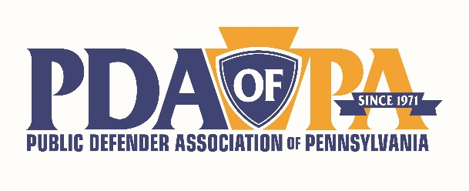
2021 Chiefs’ Conference
Presenter Contact List
ACLU of PA
- Tierra Bradford, Criminal Justice Policy Advocate, tbradford@aclupa.org
- Nyssa Taylor, Criminal Justice Policy Counsel, ntaylor@aclupa.org
Vera Institute for Justice
- Jasmine Heiss, project director of In Our Backyards, jheiss@vera.org
Quatronne Center for Fair Administration of Justice
- Marissa Boyers Bluestine, Assistant Director, mblu@law.upenn.edu

York County Defense Bar who did a Case Management System Survey
- Caty Houtman, 1st Assistant Public Defender, cbhoutman@yorkcountypa.gov
- Erin Thompson, Chief of the Conflict Counsel Office, esthompson@yorkcountypa.gov

Case Management Systems Contacts
- William Avis, Legal Edge, walvis@legaledge.com
- Keith Richey, Justice Works, keith@justiceworks.com
- Gary Egner, Equivant, gary.egner@equivant.com
- Justin Seay, Spartan, jseay@spartantechnology.com
- Jeff Hogue, Legal Server, JHogue@legalserver.rog

Law School contacts
- Jorge, C. Godoy, Jr., Director of Public Interest Programs, Temple University, Beasley School of Law, jorge.godoy@temple.edu
- Megan Lovett, Assistant Director for Public Interest and Pro Bono Initiatives, University of Pittsburgh School of Law, megan.lovett@pitt.edu
- Elizabeth Simcox, Coordinator of Externships, Widener University Commonwealth Law School, egsimcox@widener.edu
- Brenda Smith Porter, Recruitment Manager, Penn State Law, bzp72@psu.edu

Secondary Stress and Mental Well-being
- Dr. Robin Altman, robin@robinaltmanmd.com
- Brian S. Quinn, Lawyers Concerned for Lawyers Pennsylvania, brian@lclpa.org
PA Commissions & Advisory Committees
- Mark Bergstorm, Executive Director of the Pennsylvania Commission on Sentencing, mhb105@psu.edu
- Daniel A. Durst, Chief Counsel to the Supreme Court of Pennsylvania’s Rules Committees, daniel.durst@pacourts.us
- Joshua Yohe, counsel to the Criminal Procedural Rules Committee, joshua.yohe@pacourts.us

